This series of exercises will build on one another in order to demonstrate the use of CCL, XML, HTML and Javascript in MPages development.
Exercise List:
- Create HTML file and Display HTML file
- Output HTML table
- Format/style HTML with Stylesheet
- Place queried data into XML
- Convert the XML to HTML in javascript
- Create Allergies Section
- Alternating row colors
- Link to a Powerchart Tab from MPage using APPLINK
- Popups with JQuery
- Expand/Collapse Sections with JQuery
- Add Allergy Control
- Documents Section
- Allergies Section with JSON
- Update Custom Driver Program
- Edge / Chromuim Browser Compatibility

Exercise #1: Create HTML file and Display HTML file
Objectives: Introduction to MPage development using html file and a custom CCL Driver script. In this exercise we will create a CCL MPage driver and an html file. This html file will be a shell that will be populated and displayed when the MPage is opened by the CCL MPage driver script.

- Create a new CCL MPage driver program. This program will read in and open an HTML file.
- In Discern Visual Developer, open a new blank file. Save the file to the backend server (i.e. ccluserdir) as zzz_mpage_driver.prg where zzz is your initials.
- Copy the code between the dashed lines below and paste into your zzz_mpage_driver.prg. Replace the zzz in the ‘drop’ and ‘create’ commands with your initials.
- Be sure to change the name of the html file to match your own by replacing the zzz with your initials.
- Save and include your zzz_mpage_driver.prg.
-----------------------------------------------------------------------------------------------------------
drop program zzz_mpage_driver:dba go
create program zzz_mpage_driver:dba

prompt
"Output to File/Printer/MINE" = "MINE"
,"HTML File:" = "ccluserdir:zzz_mpage.html"
with outdev, html_file

/***************************************************************************
* Declare Records *
***************************************************************************/
free record mpage_rec
record mpage_rec (
1 html_file = vc
)

/***************************************************************************
* Assign prompts to record structure *
***************************************************************************/
set mpage_rec->html_file = $html_file

/***************************************************************************
* Read in HTML and display error HTML if incorrect *
***************************************************************************/
record getREQUEST (
1 Module_Dir = vc
1 Module_Name = vc
1 bAsBlob = i2
)

record getREPLY (
1 INFO_LINE[*]
2 new_line = vc
1 data_blob = gvc
1 data_blob_size = i4
%i cclsource:status_block.inc
)

; Read in the html file
set getrequest->module_dir= trim(mpage_rec->html_file, 3)
set getrequest->Module_name = ""
set getrequest->bAsBlob = 1
execute eks_get_source with replace (REQUEST,getREQUEST),replace(REPLY,getREPLY)
if(getREPLY->status_data.status = "F")
; Output No HTML File Found!
set getReply->data_blob = BUILD2(
^<html><head><title>MPage Error</title></head>^,
^<body><div>HTML file "^,mpage_rec->html_file,^" could not be found!</div>^,
CHAR(10),CHAR(13),
^</body></html>^
)
endif

/***************************************************************************
* Outputs HTML to the display *
***************************************************************************/
set _MEMORY_REPLY_STRING = getReply->data_blob

#exit_script
free record mpage_rec

end
go

-----------------------------------------------------------------------------------------------------------
- In Discern Visual Developer, open a new blank file. Save the file to the backend server (i.e. ccluserdir) as zzz_mpage.html where zzz is your initials. For example, Save As cjg_mpage.html.
- Copy the code between the dashed lines below and paste into zzz_mpage.html (where zzz is your initials). Save the file. In the code below, the <h1> tag specifies a hard-coded header that will display when the page is opened. The <div> tag with the id=’patientInfoTable’ represents a block on the page which is currently configured to be empty. This <div> will be populated with patient data by javascript in later exercises.
-----------------------------------------------------------------------------------------------------------

<!DOCTYPE html PUBLIC "-//W3C//DTD XHTML 1.0 Strict//EN" "http://www.w3.org/TR/xhtml1/DTD/xhtml1-strict.dtd">
<?xml version="1.0" encoding="UTF-8" ?>
<html xmlns="http://www.w3.org/1999/xhtml" lang="en" xml:lang="en">
<head>
<meta http-equiv="Content-Type" content="XMLCCLREQUEST,APPLINK,MPAGES_EVENT,CCLLINK" name="discern"/>
</head>
<body>
<div class="wrap">
<h1 class="ps-hd"><span>Sample MPage</span></h1>
<!-- Begin Column 1 -->
<div class="section-group" id="sectionOne">
<!-- Begin Patient Info Section -->
<div id ='patientInfo' class='section simple-table'>
<h2 class='sec-hd'><span>Patient Information</span></h2>
<div class='sec-content'>
<p class='info'>Results since admission date</p>
<div id='patientInfoTable'></div>
</div>
</div>
<!-- End Patient Info Section -->
</div>
<!-- End Column 1 -->
</div>
</body>
</html>
-----------------------------------------------------------------------------------------------------------
- Open and display the html file using your custom MPage driver by doing as follows:

- From the Discern Visual Developer Menu bar select Build->Run Prompt Program (or just type Ctrl+R)
- At the “Program to run:” prompt enter: “zzz_mpage_driver” (where zzz is your initials)
- In the “Parameters:” prompt enter: “MINE”,”ccluserdir:zzz_mpage.html” (where zzz is your initials)
- Click “Run”

- You should see “Sample MPage” display to the screen (as shown below).

Bonus Exercises
- Add the ability to see the string “Hello World” when hovering “Sample MPage” (hint: the h1 tag will require an additional attribute).
- Use inline styles to make the header text color red.

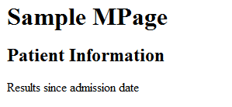
Exercise #2: Output HTML table
Objective: Use javascript to format a simple html container. Execute the javascript when the MPage is opened.

- Create a new javascript file. This javascript file will perform much of the processing for the MPage. The javascript file will be stored on a front-end server. For this class, the front-end server will be the code warehouse temp folder.
- In Notepad++:
- Open a new blank file (Ctrl+N).
- Use File->Save As and navigate to the static_content folder
- Create a new folder and assign your Cerner ID as the folder name (ie. zzz_mpage). Note that creating this folder is a one-time step.
- Open the new folder.
- Save the file as zzz_mpage.js where zzz is your initials. NOTE: Make sure to include the .js extension.

- Copy the code between the dashed lines below and paste into zzz_mpage.js . Save the file. The functions that will be executed for this exercise are getEvents() and patientInfoTable(). These functions will be discussed.
-----------------------------------------------------------------------------------------------------------
function verify(){
// 0 Object is not initialized
// 1 Loading object is loading data
// 2 Loaded object has loaded data
// 3 Data from object can be worked with
// 4 Object completely initialized
if (xmlDoc.readyState != 4){
return (false);
}
}

function loadXMLString(txt) {
try //Internet Explorer
{
//this creates the nex XML object
xmlDoc=new ActiveXObject("Microsoft.XMLDOM");
xmlDoc.async="false";
xmlDoc.onreadystatechange=verify;
xmlDoc.loadXML(txt);
return(xmlDoc);
}
catch(e)
{
try //Firefox, Mozilla, Opera, etc.
{
parser=new DOMParser();
xmlDoc=parser.parseFromString(txt,"text/xml");
return(xmlDoc);
}
catch(e) {alert(e.message);}
}
alert('returning null...');
return(null);
}

function getEvents(){
// Call functions to format html and populate sections
patientInfoTable();
}

function patientInfoTable(){
// Start building the patient information table
var tableBody = ["<table>"];

tableBody.push(
"<tr>",
"<td class='col1'>This is Column1</td>",
"<td class='col2'>This is Column2</td>",
"</tr>");
// Close the table
tableBody.push("</table>");

// Insert the table into the patient information section
document.getElementById('patientInfoTable').innerHTML = tableBody.join("");

return;
}
-----------------------------------------------------------------------------------------------------------
- We now must add a reference for the javascript to the html file. This reference will cause the javascript to be inserted into the html when the html file is opened.

Copy and paste the code between the dashed lines below into the <head> section of zzz_mpage.html, below the <meta> tag. Replace the src attribute of the <script> tag with the actual location of your js file and replace zzz in zzz_mpage.js with your initials:
-----------------------------------------------------------------------------------------------------------
<script language="javascript" type="text/javascript" src="<your save location>\yourID\zzz_mpage.js"></script>
-----------------------------------------------------------------------------------------------------------
- Finally, we must execute the javascript when the page is opened. To accomplish this, modify your zzz_mpage.html to add the text that is highlighted in yellow below as an attribute of the <body> tag:
-----------------------------------------------------------------------------------------------------------
<!DOCTYPE html PUBLIC "-//W3C//DTD XHTML 1.0 Strict//EN" "http://www.w3.org/TR/xhtml1/DTD/xhtml1-strict.dtd">
<?xml version="1.0" encoding="UTF-8" ?>
<html xmlns="http://www.w3.org/1999/xhtml" lang="en" xml:lang="en">
<head>
<meta http-equiv="Content-Type" content="XMLCCLREQUEST,APPLINK,MPAGES_EVENT,CCLLINK" name="discern"/>
<script language="javascript" type="text/javascript" src="<your save location>\yourID\zzz_mpage.js"></script>
</head>
<body onload="javascript:getEvents()">
<div class="wrap">
<h1 class="ps-hd"><span>Sample MPage</span></h1>
<!-- Begin Column 1 -->
<div class="section-group" id="sectionOne">
<!-- Begin Patient Info Section -->
<div id ='patientInfo' class='section simple-table'>
<h2 class='sec-hd'><span>Patient Information</span></h2>
<div class='sec-content'>
<p class='info'>Results since admission date</p>
<div id='patientInfoTable'></div>
</div>
</div>
<!-- End Patient Info Section -->
</div>
<!-- End Column 1 -->
</div>
</body>
</html>
-----------------------------------------------------------------------------------------------------------
- Save your zzz_mpage.html
- Execute your custom MPage driver to display your zzz_mpage.html in Discern Visual Developer.
Bonus Exercise
- Change the text color to blue in table cell 1 AFTER it is pushed to the HTML (hint: this may require adding a new id attribute to the first table cell).

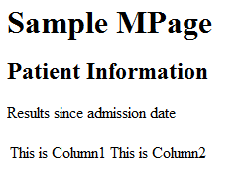
Exercise #3: Format /style HTML with Stylesheet
Objective: Introduction to the Cascading Style Sheet for controlling output.

- Create a new style sheet file. This style sheet will specify the formatting for the MPage. The style sheet file will be stored on a front-end server, in the same location as your .js file. For this class, the front-end server will be the code warehouse.
- In Notepad++:
- Open a new blank file (Ctrl+N).
- Use File->Save As and navigate to the static_content folder
- Open the folder created in Exercise 2 (ie. zzz_mpage).
- Save the file as zzz_mpage.css where zzz is your initials. NOTE: Make sure to include the .css extension.
- Copy the code between the dashed lines below and paste into your zzz_mpage.css . Save the file.
-----------------------------------------------------------------------------------------------------------
/* ============== CSS RESET ============== */
html, body, div, span, applet, object, iframe, h1, h2, h3, h4, h5, h6, p, blockquote, pre, a, abbr, acronym, address,
big, cite, code, del, dfn, em, font, img, ins, kbd, q, s, samp, small, strike, strong, sub, sup, tt, var, dl, dt,
dd, ol, ul, li, fieldset, form, label, legend, table, caption, tbody, tfoot, thead, tr, th, td {
margin: 0; padding: 0; border: 0; outline: 0; font-weight: inherit; font-style: inherit; font-size: 100%; vertical-align: baseline; }
/* remember to define focus styles! */
:focus { outline: 0; }
body { line-height: 1em; color: #000; background: #FFF; }
ol, ul { list-style: none; }
/* tables still need 'cellspacing="0"' in the markup */
table { border-collapse: separate; border-spacing: 0; }
caption, th, td { text-align: left; font-weight: normal; }
blockquote:before, blockquote:after, q:before, q:after { content: ""; }
script { display: none; height: 0; width: 0; }
input { padding: 0; margin: 0; }
html { font-size: 100.1%; }

/* ============== COMMON STYLES ============== */
html { font: 9pt Tahoma, Arial, sans-serif; }
body { text-align: left; padding: 1em;}
.wrap { cursor: default; margin: 0 auto; text-align: left;}
a { color: #003C74; text-decoration: none; cursor: pointer; }
a:hover { text-decoration: underline; }
label { color: #8F8F8F; }
hr { display: none; }
table { font-size: 100%; width: 100%; border-collapse: collapse; }
caption { position: absolute; visibility: hidden; line-height: 0; font-size: 0; overflow: hidden; height: 0; }
.prev-next { text-align: right; padding: .25em 0; }
.prev-next li { display: inline; padding: 0 .5em; border-left: 1px solid #CCC; }
.prev-next li:first-child { border-width: 0; }
.severe, .severe th, .severe td, .critical, .critical th, .critical td { color: #E50D34; font-weight: bold; }

/* Layout */
.navigation { position: absolute; visibility: hidden; }
.ps-hd { font-size: 1.3em; padding: .5em 0; margin: 0 0 .5em 0; border-bottom: 1px solid #CCC; font-weight: bold; color: #666; }
#sectionOne { float: left; width: 49%; margin: 0 1% 0 0;}
#sectionTwo { float: left; width: 49%; margin: 0 1% 0 0;}
#sectionThree { float: left; width: 32%}

/* Section Commons */
.section { background:#EFEFEF; margin: 0 0 1em 0;}
.sec-content { padding: .75em .5em 1em .5em; background: #EFEFEF; border: 1px solid #D8E3FC; border-top-color: #E7E7E7;}

.sec-hd { color: #003C74;padding-left: 1em;font-size: 1.1em; font-weight: bold;line-height: 2em; border-right: 1px solid #D8E3FC; }
.sec-hd-tgl { float: right; text-align: center; width: 1em; font-size: 1.4em; }

.info { color: #505050; font-size: 0.9em; margin: 0 0 .75em 0; padding: 0 .75em; }

.section.closed { padding: 0; }
.section.closed * { display: none; }
.section.closed .sec-hd { display: block; margin: 0;}
.section.closed .sec-hd * { display: inline; }

/* Simple Table */
.scrollDiagnostics { height: 20em; overflow-y: auto;}
.scrollProblems { height: 20em; overflow-y: auto;}
.scrollHomeMeds { height: 20em; overflow-y: auto;}
.simple-table .sec-content { padding-left: 1em; padding-right: 1em;}
.simple-table .info { padding: 0 .5em; }
.simple-table tbody { background: #FFF; }
.simple-table thead th { font-weight: normal; text-align: left; font-size: .85em; color: #505050; padding: 0 .25em .5em .25em; }
.simple-table tbody th, .simple-table td { padding: .5em .25em; border: 1px solid #E5E5E5; border-width: 1px 0; }
.simple-table thead th:first-child { visibility: hidden; }
.simple-table ul li { display: inline; border-left: 1px solid #999; padding: 0 0 0 .75em; margin: 0 0 0 .75em;}
.simple-table ul li:first-child { border: none; padding: 0; margin: 0; }
.simple-table .col1 { font-weight: normal; text-align: right; font-size: 1em; color: #505050; padding: 0.25em .25em .5em .25em; width:35%}
.simple-table .col2 { font-weight: normal; text-align: left; font-size: 1em; color: #black; padding: 0.25em .25em .5em 1.0em;width:65%}
.pat-detail {background: #FFF; padding: .5em .5em .5em .5em; z-index: 1; margin: -1px 1em 1em .5em; width: 35em; line-height: 1em; border: 1px solid black; border-color: black; }
.pat-detail.hover { position: absolute; display: none; z-index: 1000; border-color: black; background:#F4F4F4;}

-----------------------------------------------------------------------------------------------------------
- We now must add a reference for the stylesheet to the html file. This reference will cause the stylesheet to be inserted into the html when the html file is opened.

Copy and paste the code between the dashed lines below into the <head> section of your zzz_mpage.html, below the <script> tag. Replace the href attribute with the actual location of your css file and replace zzz with your initials:
-----------------------------------------------------------------------------------------------------------

<link href="<your save location>\yourID\zzz_mpage.css" rel="stylesheet" type="text/css"/>

-----------------------------------------------------------------------------------------------------------

- Save your zzz_mpage.html
- Execute your custom MPage driver to display your zzz_mpage.html in Discern Visual Developer.
Bonus Exercises
- Remove the javascript code updating the column 1 text color to blue, and instead make it blue using the stylesheet. You can remove the id attribute now as well.
- Remove the inline styles updating the h1 tag text color to red, and instead make it red using the stylesheet.

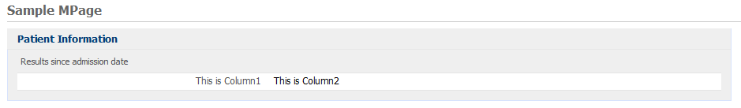
Exercise #4: Place queried data into XML
Objective: Introduction to placing data that is returned from a CCL query into XML. For this exercise, we will perform a query for simple patient information and place it into an xml structure.

- Create a new ccl program. This program will perform a CCL query to retrieve basic patient information. The program will also place the data into an xml structure.
- In Discern Visual Developer, open a new blank file. Save the file to the backend server (i.e. ccluserdir) as zzz_mpage_patientinfo.prg where zzz is your initials.
- Copy the code between the dashed lines below and paste into your zzz_mpage_patientinfo.prg. Replace the zzz in the ‘drop’ and ‘create’ commands with your initials.
-----------------------------------------------------------------------------------------------------------
drop program zzz_mpage_patientinfo:dba go
create program zzz_mpage_patientinfo:dba

prompt
"Output to File/Printer/MINE" = "MINE"
, "Person Id:" = 0.0
with outdev, personid

/* Begin the xml string */
declare sXML = vc with protect, noconstant("")

set sXML = "<?xml version='1.0' encoding='iso-8859-1' standalone='no' ?><RPT_DATA>"

/**************************************************
* Get the Patient Name, DOB and Gender *
**************************************************/
select into "nl:"
dob = format(p.birth_dt_tm,"mm/dd/yyyy;;d"),
gender = uar_get_code_display(p.sex_cd)
from
person p
plan p
where p.person_id = $personId

head report
sXML = concat(sXML, "<patientInfo>")
sXML = concat(sXML, "<patientInfo_label>Patient Name:</patientInfo_label>")
sXML = concat(sXML, "<patientInfo_result>", trim(p.name_full_formatted,3), "</patientInfo_result>")
sXML = concat(sXML, "</patientInfo>")

sXML = concat(sXML, "<patientInfo>")
sXML = concat(sXML, "<patientInfo_label>Birth Date:</patientInfo_label>")
sXML = concat(sXML, "<patientInfo_result>", trim(dob,3), "</patientInfo_result>")
sXML = concat(sXML, "</patientInfo>")

sXML = concat(sXML, "<patientInfo>")
sXML = concat(sXML, "<patientInfo_label>Gender:</patientInfo_label>")
sXML = concat(sXML, "<patientInfo_result>", trim(gender,3), "</patientInfo_result>")
sXML = concat(sXML, "</patientInfo>")
with nocounter

/* End the xml string */
set sXML = concat(sXML, "</RPT_DATA>")

call echo(sXML)

;Set public memory variable equal to our XML string
set _Memory_Reply_String = sXML

end
go

-----------------------------------------------------------------------------------------------------------
- Save and include your zzz_mpage_patientinfo.prg.
- Before writing the javascript code that calls and processes your CCL script, it is usually a good idea to test your CCL program first. We will run a simple test to ensure the program is outputting the xml the way we want. In order to do this, we will need a sample person_id to test with (you can use the one in the example below). Open a new blank file in Discern Visual Developer. Don’t worry about saving it
- We are going to run a statement to execute our program, so copy the name of your CCL object into the new blank file you just opened. You can find this in the “drop program...” statement at the top of your CCL program (for example, pmm_mpage_patientinfo).
- We need to pass the program whatever parameters it is expecting to run with. So put a space after the object name and then specify your parameters, separated by commas. It should look something like the below where the number shown is a person id local to your environment:
execute zzz_mpage_patientinfo “MINE”, 15779987.00 go
- Run the statement by going to the menu bar and clicking Build->Include/Compile.
- Select “No” when asked about saving your file.
- To view the output of your Call echo statement, go to the Menu bar and click View->Listing
- You should see your XML string with the appropriate patient data.

Bonus Exercise
- Return back the person id on the XML data.

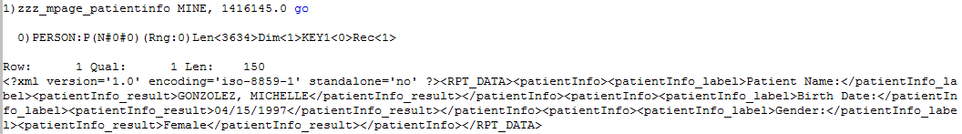
Exercise #5: Convert the XML to HTML in javascript
Objective: Load the xml into an object. Reference the items in the object in order to format the output into html.

- Open your zzz_mpage.js. Replace the entire function patientInfoTable() with the function patientInfoTable() between the dashed lines below. Find the “patInfo.open” command. Replace the ZZZ in ZZZ_MPAGE_PATIENTINFO with your initials. The new function patientInfoTable() will be discussed. Note that the function below contains a hard-coded person_id (highlighted yellow) which will need to be updated. This is temporary, and should be a patient found in the database. The hard-coded person_id will be used while testing in Discern Visual Developer. We will change the function to use context variables when we run the MPage from Power Chart in subsequent exercises.

-----------------------------------------------------------------------------------------------------------

function patientInfoTable(){
// Initialize the request object
var patInfo = new XMLCclRequest();

// Get the response
patInfo.onreadystatechange = function () {
if (patInfo.readyState == 4 && patInfo.status == 200) {
var xmlDoc = loadXMLString(patInfo.responseText);

// Get all of the parent patientInfo nodes from the xml
var pi_var = xmlDoc.getElementsByTagName("patientInfo");

// Start building the patient information table
var tableBody = ["<table>"];

// Loop through the parent nodes to get the child nodes
for (var i=0, pLen=pi_var.length; i<pLen; i++){
var pi_var2 = pi_var[i].childNodes;

tableBody.push(
"<tr>",
"<td class='col1'>",pi_var2[0].text,"</td>",
"<td class='col2'>",pi_var2[1].text,"</td>",
"</tr>");
}

// Close the table
tableBody.push("</table>");

// Insert the table into the patient information section
document.getElementById('patientInfoTable').innerHTML = tableBody.join("");
}; //if
} //function

// Call the ccl progam and send the parameter string
patInfo.open('GET', "ZZZ_MPAGE_PATIENTINFO");
//patInfo.send("MINE, $PAT_Personid$");
patInfo.send("MINE, 15779987.00 ");

return;
}
-----------------------------------------------------------------------------------------------------------

- Save your zzz_mpage.js
- Execute your custom MPage driver to display your zzz_mpage.html in Discern Visual Developer.
- You should see your patient information section displaying the appropriate patient information pulled from the database.

Bonus Exercises
- Update the javascript to NOT display the person id as a row.

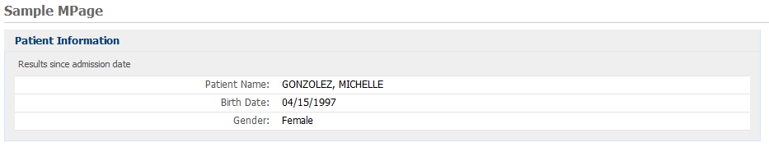

Exercise #6: Create Allergies Section
Objective: Create a new section using the Patient Information section as the model.

In this exercise, a new section will be created. The new section will display allergy information. This new section will be created using the exact steps as the patient information section.

- A new section and <div> placeholder will need to be added to your zzz_mpage.html for the allergies. Modify your zzz_mpage.html to add the new section and <div> placeholder as highlighted in yellow below. Select only the lines highlighted in yellow and paste them in the exact location shown below.
-----------------------------------------------------------------------------------------------------------

<!DOCTYPE html PUBLIC "-//W3C//DTD XHTML 1.0 Strict//EN" "http://www.w3.org/TR/xhtml1/DTD/xhtml1-strict.dtd">
<?xml version="1.0" encoding="UTF-8" ?>
<html xmlns="http://www.w3.org/1999/xhtml" lang="en" xml:lang="en">
<head>
<meta http-equiv="Content-Type" content="XMLCCLREQUEST,APPLINK,MPAGES_EVENT" name="discern"/>
<link href="<your save location>\yourID\zzz_mpage.css" rel="stylesheet" type="text/css"></link>
<script language="javascript" type="text/javascript" src="<your save location>\yourID\zzz_mpage.js"></script>
</head>
<body onload="javascript:getEvents();">
<div class="wrap">
<h1 class="ps-hd"><span>Sample MPage</span></h1>
<!-- Begin Column 1 -->
<div class="section-group" id="sectionOne">
<!-- Begin Patient Info Section -->
<div id ='patientInfo' class='section simple-table'>
<h2 class='sec-hd'><span>Patient Information</span></h2>
<div class='sec-content'>
<p class='info'>Results since admission date</p>
<div id='patientInfoTable'></div>
</div>
</div>
<!-- End Patient Info Section -->
<!-- Begin Allergy Section -->
<div id ='allergyInfo' class='section simple-table'>
<h2 class='sec-hd'><span>Allergies </span></h2>
<div class='sec-content'>
<p class='info'>Active Allergies</p>
<div id='allergyTable'></div>
</div>
</div>
<!-- End Allergy Section -->
</div>
<!-- End Column 1 -->
</div>
</body>
</html>
-----------------------------------------------------------------------------------------------------------

- Save your zzz_mpage.html
- Execute your custom MPage driver to display zzz_mpage.html in Discern Visual Developer to confirm that you are successfully displaying a blank allergy section.
- Create a new CCL program. This program will perform a CCL query to retrieve the patient allergies. The program will also place the data into an xml structure.
- In Discern Visual Developer, open a new blank file. Save the file to the backend server (i.e. ccluserdir) as zzz_mpage_allergies.prg where zzz is your initials.
- Copy the code between the dashed lines below and paste into your zzz_mpage_allergies.prg. Replace the zzz in the ‘drop’ and ‘create’ commands with your initials.
- Save and include your zzz_mpage_allergies.prg.

-----------------------------------------------------------------------------------------------------------
drop program zzz_mpage_allergies:dba go
create program zzz_mpage_allergies:dba

prompt
"Output to File/Printer/MINE" = "MINE"
, "Person Id:" = 0.0
with outdev, personid

/* Begin the xml string */
declare sXML = vc with protect, noconstant("")

set sXML = "<?xml version='1.0' encoding='iso-8859-1' standalone='no' ?><RPT_DATA>"

/**************************************************
* Get the Allergies and Reactions *
**************************************************/

declare reactionString = vc with public, noconstant("")

select into "nl:"
sortName = if( n.nomenclature_id = 0 and TRIM( a.substance_ftdesc ) != "" )
cnvtupper(a.SUBSTANCE_FTDESC)
else
cnvtupper(n.SOURCE_STRING)
endif

from
allergy a,
nomenclature n,
reaction r,
nomenclature n2

plan a
where a.person_id = $PersonId
and a.substance_nom_id > 0.0
and a.cancel_dt_tm = NULL
and a.active_ind + 0 = 1

join n
where n.nomenclature_id = a.substance_nom_id

join r
where r.allergy_id = outerjoin(a.allergy_id)
and r.end_effective_dt_tm > outerjoin(sysdate)
and r.active_ind = outerjoin(1)

join n2
where n2.nomenclature_id = outerjoin(r.reaction_nom_id)

order by sortName, a.allergy_id

head report
cnt = 0
reactionString = ""

head a.allergy_id
reactionString = ""

cnt = cnt + 1
sXML = concat(sXML, "<allergy>")

if( n.nomenclature_id = 0 and TRIM( a.substance_ftdesc ) != "" )
sXML = concat(sXML, "<allergy_name>", a.SUBSTANCE_FTDESC, "</allergy_name>")
else
sXML = concat(sXML, "<allergy_name>", trim(n.SOURCE_STRING), "</allergy_name>")
endif

detail
if( n2.nomenclature_id = 0 and TRIM( r.reaction_ftdesc ) != "" )
if(reactionString > " ")
reactionString = build2(reactionString,", ",trim(r.reaction_ftdesc,3))
else
reactionString = concat(trim(r.reaction_ftdesc,3))
endif
else
if(reactionString > " ")
reactionString = build2(reactionString,", ",trim(n2.source_string,3))
else
reactionString = concat(trim(n2.source_string,3))
endif
endif

foot a.allergy_id
if (reactionString = "")
reactionString = "None Documented"
endif
sXML = concat(sXML, "<allergy_reaction>", reactionString, "</allergy_reaction>")
sXML = concat(sXML, "<allergy_id>", trim(BUILD2(a.allergy_id),3), "</allergy_id>")

sXML = concat(sXML, "</allergy>")
with nocounter

/* End the xml string */
set sXML = concat(sXML, "</RPT_DATA>")

call echo(sXML)

;Set public memory variable equal to our XML string
set _Memory_Reply_String = sXML

end
go

-----------------------------------------------------------------------------------------------------------

- Run a test statement exactly as we did before to see your CCL output, substituting the allergies program name instead of the patient info one. Example:
execute zzz_mpage_allergies “MINE”, 15779987.00 go
- Verify that your CCL is running error free and outputting your XML string.
- Modify the zzz_mpage.js to add the processing necessary for the allergy section. Copy the code between the dashed lines below and paste at the bottom of your zzz_mpage.js (i.e. immediately following the patientInfoTable() function. The code below is a function so it can go anywhere in the js, but just paste it at the bottom of the js to make it simple. After pasting into the js, change the ZZZ in the algyInfo.open to your initials and update the hard-coded person id (highlighted in yellow) to a patient with allergies. This new function will be discussed following this exercise.

-----------------------------------------------------------------------------------------------------------
function allergyInfoTable(){
// Initialize the request object
var algyInfo = new XMLCclRequest();

// Get the response
algyInfo.onreadystatechange = function () {
if (algyInfo.readyState == 4 && algyInfo.status == 200) {
var xmlDoc = loadXMLString(algyInfo.responseText);

// Get all of the parent allergy nodes from the xml
var all_var = xmlDoc.getElementsByTagName("allergy");

// Start building the allergy table
var tableBody = ["<table>"];
// Loop through the parent nodes to get the child nodes
for (var i=0, aLen=all_var.length;i<aLen;i++){
var all_var2 = all_var[i].childNodes;

tableBody.push(
"<tr>",
"<td class='col1'>",all_var2[0].text,"</td>",
"<td class='col2'>",all_var2[1].text,"</td>",
"</tr>");
}

// Close the table
tableBody.push("</table>");

// Insert the table into the allergy section
document.getElementById('allergyTable').innerHTML = tableBody.join("");
}; //if
} //function

// Call the ccl program and send the parameter string
algyInfo.open('GET', "ZZZ_MPAGE_ALLERGIES");
//algyInfo.send("MINE, $PAT_Personid$");
algyInfo.send("MINE, 15779987.00 ");

return;
}
-----------------------------------------------------------------------------------------------------------

- Add the call to the new allergyInfoTable() to the getEvents() function. Copy the line highlighted below and paste in the getEvents() function as shown below.
-----------------------------------------------------------------------------------------------------------

function getEvents(){
// Call functions to format html and populate sections
patientInfoTable();
allergyInfoTable();
}
-----------------------------------------------------------------------------------------------------------
- Save your zzz_mpage.js
- Execute your custom MPage driver to display your zzz_mpage.html in Discern Visual Developer.

Bonus Exercises
- Update styles so that ONLY the patient information section shows blue text on the first column. All other sections should have text with the color “#505050”.
- Update the CCL and XML string to return both the SUBSTANCE_FTDESC and SOURCE_STRING columns. Update the javascript to do the evaluation on which one to display (hint: one will be blank).

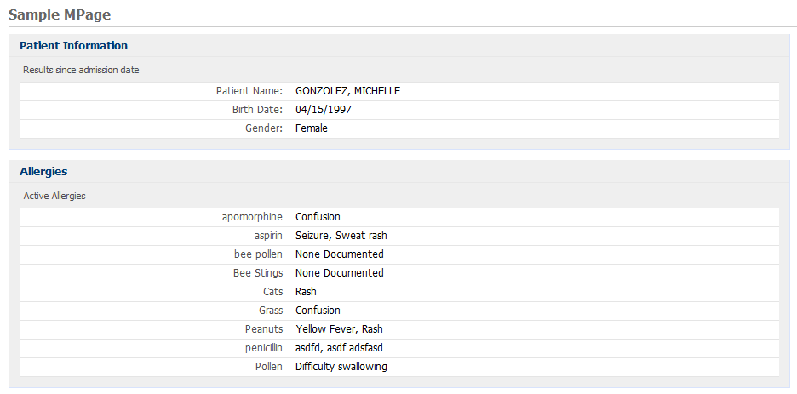
Exercise #7: Alternating row colors
Objective: Create a variable class in order to give color to alternate rows on the allergies section table. Use of javascript MOD operator to determine if row is odd or even.

- Open zzz_mpage.js where zzz is your initials.
- Go to the allergyInfoTable() function.
- On the first line of the allergyInfoTable() function, create two variables as shown below. These variables will serve as the odd/even indicators. Copy and paste the variable declarations highlighted in yellow below into the beginning of the allergyInfoTable() function.
var mod_i = 0;
var OddRow = "";

- On the first line inside the FOR loop which loops through the parent nodes to get the child nodes, add the following:

mod_i = i%2;
OddRow = "";
if (mod_i)
OddRow = " class='odd_row'";

- In the <td> tags where you currently have the hard-coded classes of ‘col1’ and ‘col2’, modify each class to add the variable OddRow. See the yellow highlighted code below for adding the variable OddRow to the classes. Save your zzz_mpage.js.

tableBody.push(
"<tr",OddRow,">",
"<td class='col1'>",all_var2[0].text,"</td>",
"<td class='col2'>",all_var2[1].text,"</td>",
"</tr>");
- Open zzz_mpage.css where zzz is your initials. We are going to create styles identical to the .col1 and .col2 styles, except we will add a background color to produce the alternating color effect. Paste the highlighted row, from below, anywhere into zzz_mpage.css. As you can see in the example below, your css should have both the original unhighlighted text as well as the new highlighted text. Note the only difference is the background color in the odd styles. Save zzz_mpage.css.

.pat-detail.hover { position: absolute; display: none; z-index: 1000; border-color: black; background:#F4F4F4;}
.simple-table .odd_row {background:#F4F4F4;}

- Execute your custom MPage driver to display your zzz_mpage.html in Discern Visual Developer.

Bonus Exercises
- Change the color of the odd row color to one of your choosing.
- Update the javascript/css so that the even rows have their own color too.

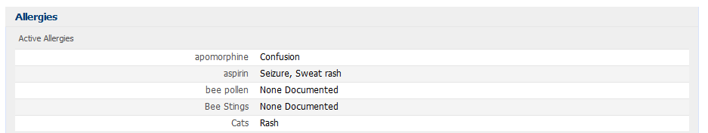
Exercise #8: Link to a Powerchart Tab from MPage using APPLINK
Objective: Transform section headers into links in order to link to a specified Powerchart tab from the MPage. Introduction to APPLINK.

APPLINK is a canned javascript function that is included in the MPages exception package. APPLINK allows users to launch a Cerner application from an MPage. In MPages the most common use of APPLINK is to open a Power Chart tab from an MPage.
APPLINK requires the person_id and encntr_id of the patient whose chart is open. We can use context variables, which powerchart passes to the discern report tab, to execute APPLINK.
- Open zzz_mpage.js. Copy the code between the dashed lines below and paste into zzz_mpage.js. The code below is a function so it can go anywhere in the js, but just paste it at the bottom of the js to make it simple. This function is used to make the formatting of the APPLINK simpler.
-----------------------------------------------------------------------------------------------------------
function tabLink (desc,firstTab,appl) {
var nMode = 0;
var vcAppName = appl;
var vcDescription = desc;
var vcParams = "/PERSONID=$PAT_PERSONID$ /ENCNTRID=$VIS_ENCNTRID$ /FIRSTTAB="+firstTab;
return ["<a title='Click to go to ",firstTab," Tab' href='javascript:APPLINK(",nMode,",\"",vcAppName,"\",\"",vcParams,"\");'>",vcDescription,"</a>"].join("");
}
-----------------------------------------------------------------------------------------------------------

- Copy the highlighted code between the dashed lines below and paste into your patientInfoTable() function in the exact location as below in zzz_mpage.js. The code will use the tabLink function to build the APPLINK and then insert the link into the Patient Information section header. The first highlighted line below shows how to use the tabLink function that you just pasted from step #1 above into zzz_mpage.js. The tabLink function takes 3 arguments. The first argument is the display value of the link. The second argument is the tab that you want to open. Third argument is the application you want to launch. The second highlighted section below shows that the link is being inserted into the section header of the patient information section.
-----------------------------------------------------------------------------------------------------------
function patientInfoTable(){
// Initialize the request object
var patInfo = new XMLCclRequest();

// Get the response
patInfo.onreadystatechange = function () {
if (patInfo.readyState == 4 && patInfo.status == 200) {
var xmlDoc = loadXMLString(patInfo.responseText);

// Get all of the parent patientInfo nodes from the xml
var pi_var = xmlDoc.getElementsByTagName("patientInfo");

// Start building the patient information table
var tableBody = ["<table>"];

// Loop through the parent nodes to get the child nodes
for (var i=0, pLen=pi_var.length; i<pLen; i++){
var pi_var2 = pi_var[i].childNodes;

tableBody.push(
"<tr>",
"<td class='col1'>",pi_var2[0].text,"</td>",
"<td class='col2'>",pi_var2[1].text,"</td>",
"</tr>");
}

// Close the table
tableBody.push("</table>");

// Insert the table into the patient information section
document.getElementById('patientInfoTable').innerHTML = tableBody.join("");

var link = tabLink("Custom Patient Information","Patient Information","$APP_APPNAME$");

// Insert the link into the patient information section header
document.getElementById('patHeader').innerHTML = link;
}; //if
} //function

// Call the ccl progam and send the parameter string
patInfo.open('GET', "ZZZ_MPAGE_PATIENTINFO");
//patInfo.send("MINE, $PAT_Personid$");
patInfo.send("MINE, 15779987.00");

return;
}
-----------------------------------------------------------------------------------------------------------
- To test the APPLINK, we will need to open the MPage in Powerchart. Now is the time to comment out the hard coded person_id in the XMLCclRequest.send and allow XMLCclRequest.send to use the context variables provided by Power Chart. The instructor will discuss the context variables. In the patientInfoTable function and the allergyInfoTable function, uncomment the XMLCclRequest.send line that uses the context variables and comment out the line that uses the hard-coded person_id as follows (NOTE: comments in javascript are two consecutive “/”):
-----------------------------------------------------------------------------------------------------------
patInfo.send("MINE, $PAT_Personid$");
//patInfo.send("MINE, 9502518");
-----------------------------------------------------------------------------------------------------------

algyInfo.send("MINE, $PAT_Personid$");
//algyInfo.send("MINE, 9502518");

-----------------------------------------------------------------------------------------------------------
- Save your zzz_mpage.js
- Open your zzz_mpage.html. add an attribute to the <span> tag that starts the Patient Information section header, adding id=’patHeader’ as shown in yellow highlight below. Only copy and paste the code highlighted in yellow. The addition of the id to the <span> will allow the js to insert the link into the header.
-----------------------------------------------------------------------------------------------------------

<!DOCTYPE html PUBLIC "-//W3C//DTD XHTML 1.0 Strict//EN" "http://www.w3.org/TR/xhtml1/DTD/xhtml1-strict.dtd">
<?xml version="1.0" encoding="UTF-8" ?>
<html xmlns="http://www.w3.org/1999/xhtml" lang="en" xml:lang="en">
<head>
<meta http-equiv="Content-Type" content="XMLCCLREQUEST,APPLINK,MPAGES_EVENT" name="discern"/>
<link href="<your save location>\yourID\zzz_mpage.css" rel="stylesheet" type="text/css"></link>
<script language="javascript" type="text/javascript" src="<your save location>\yourID\zzz_mpage.js"></script>
</head>
<body onload="javascript:getEvents();">
<div class="wrap">
<h1 class="ps-hd"><span>Sample MPage</span></h1>
<!-- Begin Column 1 -->
<div class="section-group" id="sectionOne">
<!-- Begin Patient Info Section -->
<div id ='patientInfo' class='section simple-table'>
<h2 class='sec-hd'><span id="patHeader">Patient Information</span></h2>
<div class='sec-content'>
<p class='info'>Results since admission date</p>
<div id='patientInfoTable'></div>
</div>
</div>
<!-- End Patient Info Section -->
<!-- Begin Allergy Section -->
<div id ='allergyInfo' class='section simple-table'>
<h2 class='sec-hd'><span>Allergies </span></h2>
<div class='sec-content'>
<p class='info'>Active Allergies</p>
<div id='allergyTable'></div>
</div>
</div>
<!-- End Allergy Section -->
</div>
<!-- End Column 1 -->
</div>
</body>
</html>

-----------------------------------------------------------------------------------------------------------
- Save zzz_mpage.html
- Create Power Chart tab in prefmaint to display your MPage. Please let the instructor do this step as more than one person in Prefmaint can cause it to behave erratically.
- See Help in Discern Visual Developer for detailed instructions for creating new MPage tab in prefmaint.
- Make sure to use “Discern Report” tab type at the “Chart” level, and also use the following as parameters:
  - Report Name: zzz_mpage_driver
  - Report Parameters: MINE,^ccluserdir:zzz_mpage.html^
- After the Power Chart tab has been created, login to Power Chart and launch your MPage by opening the tab you created. You should see that the section header of the Patient Information section is now a link to the Patient Information tab in Power Chart. NOTE: Any changes in Prefmaint require completely closing Powerchart as the tab settings are cached upon opening of Powerchart!!!

Bonus Exercises
- Create a link for the allergies section to the allergies tab.
- Update allergies link to open the Add Allergy window when linking to the allergies tab (hint: refer to the following link for help APPLINK Explorer Help).

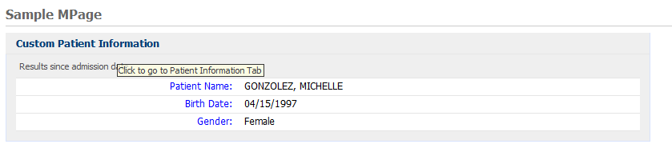
Exercise #9: Popups with JQuery
Objective: Use JQuery javascript library to hover over an MPage item and display a pop up.

In this exercise, we will install the jquery library as well as create a custom function to display the pop ups using the jquery library. We will then modify column 2 of the Patient information table so that hovering over each cell in column 2 triggers a popup message to display.

- Modify your zzz_mpage_patientinfo.prg so that it stores the information to be displayed in the pop ups in an xml child node. Add the lines highlighted in yellow below to your zzz_mpage_patientinfo.prg. Save and include zzz_mpage_patientinfo.prg.

-----------------------------------------------------------------------------------------------------------

/**************************************************
* Get the Patient Name,DOB and Gender *
**************************************************/
select into "nl:"
dob = format(p.birth_dt_tm,"mm/dd/yyyy;;d"),
gender = uar_get_code_display(p.sex_cd)
from
person p
plan p
where p.person_id = $personId

head report
sXML = concat(sXML, "<patientInfo>")
sXML = concat(sXML, "<patientInfo_label>Patient Name:</patientInfo_label>")
sXML = concat(sXML, "<patientInfo_result>", p.name_full_formatted, "</patientInfo_result>")
sXML = concat(sXML, "<patientInfo_detail>This person's name is: ",p.name_full_formatted,"</patientInfo_detail>")
sXML = concat(sXML, "</patientInfo>")

sXML = concat(sXML, "<patientInfo>")
sXML = concat(sXML, "<patientInfo_label>Birth Date:</patientInfo_label>")
sXML = concat(sXML, "<patientInfo_result>", dob , "</patientInfo_result>")
sXML = concat(sXML, "<patientInfo_detail>This person's birthdate is: ",dob,"</patientInfo_detail>")
sXML = concat(sXML, "</patientInfo>")

sXML = concat(sXML, "<patientInfo>")
sXML = concat(sXML, "<patientInfo_label>Gender:</patientInfo_label>")
sXML = concat(sXML, "<patientInfo_result>", gender , "</patientInfo_result>")
sXML = concat(sXML, "<patientInfo_detail>This person's gender is: ",gender,"</patientInfo_detail>")
sXML = concat(sXML, "</patientInfo>")
with nocounter

-----------------------------------------------------------------------------------------------------------

- We now need to create a custom function that will retrieve the title from an element with the class of “col2” and display the pop up details using jquery. This custom function will probably be reused by many MPages so let’s begin to create a javascript library of common functions that any MPage can use.
- Create a new javascript file. This js file will contain common functions that any MPage can use. . The javascript file will be stored on a front-end server. For this class, the front-end server will be the code warehouse.
In Notepad++:
- Open a new blank file (Ctrl+N).
- Use File->Save As and navigate to the static_content folder
- Open the folder created in Exercise 2 (ie. zzz_mpage).
- Save the file as zzz_mpage_common.js where zzz is your initials. NOTE: Make sure to include the .js extension.

- Copy the code between the dashed lines below and paste into your zzz_mpage_common.js. Save the file. Note that function is being made an extension of JQuery (aka “$”).
-----------------------------------------------------------------------------------------------------------
$.extend({
reInitPopUps : function( id ){
//add the class of hover to all elements with the class of col2
$("#"+id+" .col2").hover(
function(){
if (this.title > " "){
this.tip = this.title;
this.title = "";
$(['<div id="tooltip">',this.tip,'</div>'].join("")).css( {
position: 'absolute',
width: '400px',
top: event.clientY+20,
left: event.clientX+40,
'font-weight': 'bold',
border: '1px solid #000',
padding: '10px 10px 10px 10px',
'background-color': '#ffc',
opacity: 1.00
}).appendTo("body").fadeIn(0);
}
},
function(){
if (this.tip > " "){
$("#tooltip").remove();
this.title = this.tip;
}
});
}});
-----------------------------------------------------------------------------------------------------------
- Modify the patientInfoTable function in your zzz_mpage.js so that the values in column 2 are now trigger elements for the popups. A common method of using jquery to display a pop up is to utilize the “title” property of the triggering element. The “title” is usually used for the little “tip” window that you see when hovering over an element on a web page. We will use the title of the column 2 <td> as an intermediary for our pop up. The first step is to add the details that we want to display in the pop up to the title of the <td> of the second column of the patient information table. See the highlighted code below. Copy the yellow highlighted code below and paste into the <td> tag for column 2 as shown.
-----------------------------------------------------------------------------------------------------------

function patientInfoTable(){
// Initialize the request object
var patInfo = new XMLCclRequest();

// Get the response
patInfo.onreadystatechange = function () {
if (patInfo.readyState == 4 && patInfo.status == 200) {
var xmlDoc = loadXMLString(patInfo.responseText);

// Get all of the parent patientInfo nodes from the xml
var pi_var = xmlDoc.getElementsByTagName("patientInfo");

// Start building the patient information table
var tableBody = ["<table>"];

// Loop through the parent nodes to get the child nodes
for (var i=0, pLen=pi_var.length; i<pLen; i++){
var pi_var2 = pi_var[i].childNodes;

tableBody.push(
"<tr>",
"<td class='col1'>",pi_var2[0].text,"</td>",
"<td class='col2' title=\"",pi_var2[2].text,"\">",pi_var2[1].text,"</td>",
"</tr>");
}

// Close the table
tableBody.push("</table>");

// Insert the table into the patient information section
document.getElementById('patientInfoTable').innerHTML = tableBody.join("");

var link = tabLink("Custom Patient Information","Patient Information","$APP_APPNAME$");

// Insert the link into the patient information section header
document.getElementById('patHeader').innerHTML = link;
//Initialize the col2 elements as hovers
$.reInitPopUps('patientInfoTable');
}; //if
} //function

// Call the ccl progam and send the parameter string
patInfo.open('GET', "ZZZ_MPAGE_PATIENTINFO");
patInfo.send("MINE, $PAT_Personid$");
//patInfo.send("MINE,5873913.00");

return;
}
-----------------------------------------------------------------------------------------------------------

- Save zzz_mpage.js.
- For this class, jquery.min.js has already been installed. Please ask the instructor where it is located. You will just need to add this reference to your html file. See step #8.
- Open your zzz_mpage.html. Add the references for the jquery.min.js and zzz_mpage_common.js to the <head> section. Copy and paste the code between the dashed lines below into the <head> section of your zzz_mpage.html, below the <meta> tag. Make sure the jquery reference is the first one after the <meta> tag, with the mpage_common file following it. Keep the reference to jquery.min.js as is. For the zzz_mpage_common.js file, replace the src entry with the actual location of zzz_mpage_common.js and replace zzz in zzz_mpage_common.js with your initials

-----------------------------------------------------------------------------------------------------------
<script language="javascript" type="text/javascript" src="<your save location>\yourID\zzz_mpage.js"></script>

<script language="javascript" type="text/javascript" src="<your save location>\yourID\jquery.min.js"></script>
<script language="javascript" type="text/javascript" src="<your save location>\yourID\zzz_mpage_common.js"> </script>

-----------------------------------------------------------------------------------------------------------

- Save zzz_mpage.html
- Open or refresh your MPage in Power Chart.
- Hover over the cells in column 2 of the Patient Information section to see the jquery popups.

Bonus Exercises
- Cut and copy the reInitPopUps jQuery function from zzz_mpage_common.js to your zzz_mpage.js file. Refresh page, and an error should occur. Fix this error without putting it back into the zzz_mpage_common.js file. (After done debugging, please put the function back into the zz_mpage_common.js file)
- Using the same reInitPopUps function, have it convert the title on the patient information section header into a pop-up as well. This can be done multiple ways, but try to reuse as much code as possible. You may have to reference the jQuery API at www.jquery.com.
- After completing bonus exercise 2, update the allergies header to have a pop-up.

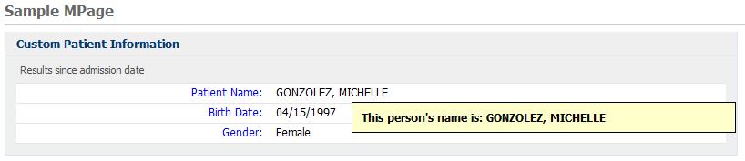
Exercise #10: Expand/Collapse Sections with JQuery
Objective: Use JQuery to expand and collapse sections.

- Open your zzz_mpage.html. Add a toggle button to the section header of Patient Information and Allergy sections. In order to do this, copy the code highlighted in yellow below and paste in the exact location of zzz_mpage.html as shown below. Save zzz_mpage.html.

-----------------------------------------------------------------------------------------------------------

<!DOCTYPE html PUBLIC "-//W3C//DTD XHTML 1.0 Strict//EN" "http://www.w3.org/TR/xhtml1/DTD/xhtml1-strict.dtd">
<?xml version="1.0" encoding="UTF-8" ?>
<html xmlns="http://www.w3.org/1999/xhtml" lang="en" xml:lang="en">
<head>
<meta http-equiv="Content-Type" content="XMLCCLREQUEST,APPLINK,MPAGES_EVENT" name="discern"/>
<link href="<your save location>\yourID\zzz_mpage.css" rel="stylesheet" type="text/css"></link>
<script language="javascript" type="text/javascript" src="<your save location>\yourID\zzz_mpage.js"></script>
<script language="javascript" type="text/javascript" src="<your save location>\yourID\jquery.min.js"></script>
<script language="javascript" type="text/javascript" src="<your save location>\yourID\zzz_mpage_common.js"></script>
</head>
<body onload="javascript:getEvents();">
<div class="wrap">
<h1 class="ps-hd"><span>Sample MPage</span></h1>
<!-- Begin Column 1 -->
<div class="section-group" id="sectionOne">
<!-- Begin Patient Info Section -->
<div id ='patientInfo' class='section simple-table'>
<span class='toggleButton'>-</span><h2 class='sec-hd'><span id="patHeader">Patient Information</span></h2>
<div class='sec-content'>
<p class='info'>Results since admission date</p>
<div id='patientInfoTable'></div>
</div>
</div>
<!-- End Patient Info Section -->
<!-- Begin Allergy Section -->
<div id ='allergyInfo' class='section simple-table'>
<span class='toggleButton'>-</span><h2 class='sec-hd'><span>Allergies </span></h2>
<div class='sec-content'>
<p class='info'>Active Allergies</p>
<div id='allergyTable'></div>
</div>
</div>
<!-- End Allergy Section -->
</div>
<!-- End Column 1 -->
</div>
</body>
</html>
-----------------------------------------------------------------------------------------------------------

- Open zzz_mpage.css. Add the following style for the class of toggleButton to the stylesheet. Add this line highlighted in yellow below at the end of the /* Section Commons */ section of the style sheet. Save zzz_mpage.css.
-----------------------------------------------------------------------------------------------------------

.toggleButton {float:right; padding-top:0.4em; text-align: center; width: 1em; height: 1em;font-size: 1.4em; font-weight:bold; cursor:pointer;}
-----------------------------------------------------------------------------------------------------------

- Open zzz_mpage_common.js. Paste the code between the dashed lines below into zzz_mpage_common.js, outside of the other function. Save zzz_mpage_common.js
-----------------------------------------------------------------------------------------------------------

$(document).ready(function() {
$('.toggleButton').click(function() {
if ($(this).siblings("div:first").is(":hidden"))
{
$(this).html("-");
$(this).siblings("div:first").slideDown("fast");
}
else
{
$(this).html("+");
$(this).siblings("div:first").slideUp("fast");
}
});
});
-----------------------------------------------------------------------------------------------------------

- Open or refresh your MPage in Power Chart.
- Click the “+” and/or “-“ in section headers of the sections to see the sections expand and collapse.

Bonus Exercises
- Set-up the Allergies section to be collapsed by default on page load modifying the html only.
- Revert the changes performed on bonus 1, and do the same modifying the javascript only.
- Create a button to collapse all or expand all sections. This can be placed in the header.
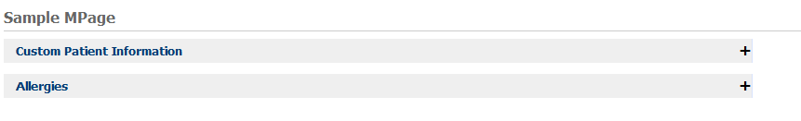

Exercise #11: Add Allergy Control
Objective: Use MPAGES_EVENT to add the allergy control to an MPage.

- Modify zzz_mpage.js to add a function to bring up the allergy control. Copy the code between the dashed lines below and paste into zzz_mpage.js. This function will be called when the “+” in the Allergies section header is clicked and we will use context variables to pass the patient identifiers. Instructor will discuss this function.

-----------------------------------------------------------------------------------------------------------

function addAllergy() {
var paramString = "$PAT_PERSONID$|$VIS_ENCNTRID$|0|0|||0||0|0";
MPAGES_EVENT("Allergy", paramString);
allergyInfoTable();
} //end addAllergy
-----------------------------------------------------------------------------------------------------------

- Modify zzz_mpage.html to add a “+” in the Allergies section header and turn it into a link. We must add an <a> tag, putting the “+” in between the opening and closing tags. Whatever you surround with the <a> and </a> is what you click on to execute the link. Carefully copy the code highlighted in yellow below and paste in the exact location shown below.

-----------------------------------------------------------------------------------------------------------

<!-- Begin Allergy Section -->
<div id ='allergyInfo' class='section simple-table'>
<span class='toggleButton'>-</span>
<h2 class='sec-hd'>
<span>Allergies </span>
<a href='javascript:addAllergy();' title="Click to Add/Modify Allergies">+</a>
</h2>
<div class='sec-content'>
<p class='info'>Active Allergies</p>
<div id='allergyTable'></div>
</div>
</div>
<!-- End Allergy Section -->

-----------------------------------------------------------------------------------------------------------

- Save zzz_mpage.html.
- Open or refresh your MPage in Power Chart.
- Click the “+” in the Allergy section header to bring up the Allergy control.

Bonus Exercises
- Create each allergy as a link such that when clicked, it will open up the modal allergy window to modify the selected allergy. Help with MPAGES_EVENT can be found here https://wiki.ucern.com/display/public/1101discernHP/MPAGES_EVENT+using+Discern+Explorer.
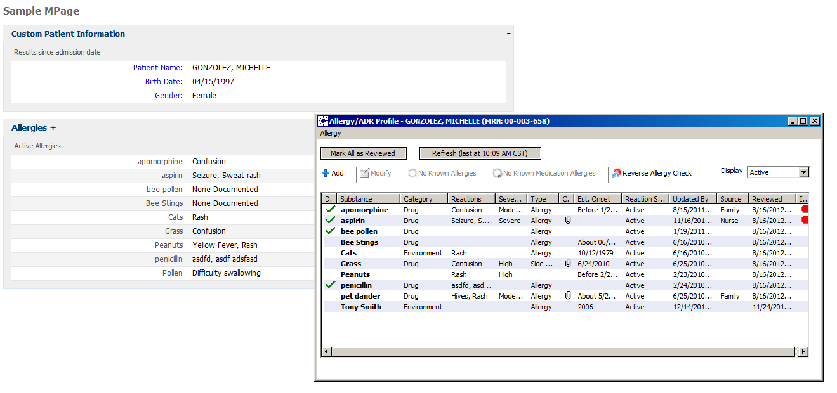

Exercise #12: Document Section
Objective: Use CCLLINK to display documents from document section.

For this exercise you will add a new section to the MPage that you developed on day 1. This new section will display a list of documents (clinical notes) for the patient. When the user clicks on the “date” for each document in the list, the corresponding document will display.
- The instructor will provide a program named mp_rtf_view.prg. This is the program that will retrieve the document when the date field is clicked in the section. Install this program in the domain and include it. This only needs to be done by one person.
- A new section and <div> placeholder will need to be added to zzz_mpage.html for the documents. Modify zzz_mpage.html to add the new section and <div> placeholder as highlighted in yellow below. Select only the lines highlighted in yellow and paste them in the exact location shown below.

-----------------------------------------------------------------------------------------------------------

<!DOCTYPE html PUBLIC "-//W3C//DTD XHTML 1.0 Strict//EN" "http://www.w3.org/TR/xhtml1/DTD/xhtml1-strict.dtd">
<?xml version="1.0" encoding="UTF-8" ?>
<html xmlns="http://www.w3.org/1999/xhtml" lang="en" xml:lang="en">
<head>
<meta http-equiv="Content-Type" content="XMLCCLREQUEST,APPLINK,MPAGES_EVENT" name="discern"/>
<link href="<your save location>\yourID\zzz_mpage.css" rel="stylesheet" type="text/css"></link>
<script language="javascript" type="text/javascript" src="<your save location>\yourID\zzz_mpage.js"></script>
<script language="javascript" type="text/javascript" src="<your save location>\yourID\jquery.min.js"></script>
<script language="javascript" type="text/javascript" src="<your save location>\yourID\zzz_mpage_common.js"></script>
</head>
<body onload="javascript:getEvents();">
<div class="wrap">
<h1 class="ps-hd"><span>Sample MPage</span></h1>
<!-- Begin Column 1 -->
<div class="section-group" id="sectionOne">
<!-- Begin Patient Info Section -->
<div id ='patientInfo' class='section simple-table'>
<span class='toggleButton'>-</span><h2 class='sec-hd'><span id="patHeader">Patient Information</span></h2>
<div class='sec-content'>
<p class='info'>Results since admission date</p>
<div id='patientInfoTable'></div>
</div>
</div>
<!-- End Patient Info Section -->
<!-- Begin Allergy Section -->
<div id ='allergyInfo' class='section simple-table'>
<span class='toggleButton'>-</span>
<h2 class='sec-hd'>
<span>Allergies </span>
<a href='javascript:addAllergy();' title="Click to Add/Modify Allergies">+</a>
</h2>
<div class='sec-content'>
<p class='info'>Active Allergies</p>
<div id='allergyTable'></div>
</div>
</div>
<!-- End Allergy Section -->
</div>
<!-- End Column 1 -->
<!-- Begin Column 2 -->
<div class="section-group" id="sectionTwo">
<!-- Begin Document Section -->
<div id='documents' class='section simple-table'>
<h2 class='sec-hd'><span>Documents</span></h2>
<div class='sec-content'>
<p class='info'>Documents for past 6 months</p>
<div id='documentTable'></div>
</div>
</div>
<!-- End Document Section -->
</div>
<!-- End Column 2 -->
</div>
</body>
</html>
-----------------------------------------------------------------------------------------------------------

- Save zzz_mpage.html
- Create a new program to query for the documents. Name the program zzz_mpage_documents.prg where zzz is your initials. The query for the documents and the placement of the data into xml is shown below between the dashed lines. Copy and paste the code below into your zzz_mpage_documents.prg. Replace the instances of zzz with your initials. Save and include zzz_mpage_documents.prg.

-----------------------------------------------------------------------------------------------------------
drop program zzz_mpage_documents:dba go
create program zzz_mpage_documents:dba

prompt
"Output to File/Printer/MINE" = "MINE"
, "Person Id:" = 0.0
, "Encounter Id:" = 0.0

with outdev, personid, encntrid

declare inErrorCd = f8 with public, noconstant(uar_get_code_by("MEANING",8,"INERROR"))
declare DOCCd = f8 with public,constant(uar_get_code_by("MEANING", 53, "DOC"))

/* Begin the xml string */
declare sXML = vc with protect, noconstant("")

set sXML = "<?xml version='1.0' encoding='iso-8859-1' standalone='no' ?><RPT_DATA>"

/******************************************************
* Get the Document Title, Date and Event_Id *
******************************************************/
select into "nl:"
evtDate = format(ce.event_end_dt_tm,"mm/dd/yyyy hh:mm;;dq"),
evtTitle = ce.event_tag,
evtId = cnvtstring(ceb.event_id)
from
clinical_event ce,
ce_blob ceb

plan ce
where ce.person_id = $PersonId
and ce.event_end_dt_tm >= cnvtlookbehind("6 M",cnvtdatetime(curdate,curtime3))
and ce.valid_until_dt_tm > cnvtdatetime(curdate,curtime3)
and ce.encntr_id = $encntrid
and ce.result_status_cd != inErrorCd
and ce.event_class_cd = DOCCd
join ceb
where ceb.event_id = ce.event_id
and ceb.valid_until_dt_tm > cnvtdatetime(curdate,curtime3)

order by ce.event_end_dt_tm desc

head ceb.event_id
sXML = concat(sXML, "<documents>")
sXML = concat(sXML, "<document_date>",evtDate,"</document_date>")
sXML = concat(sXML, "<document_title>",evtTitle,"</document_title>")
sXML = concat(sXML, "<document_event_id>",evtId,"</document_event_id>")
sXML = concat(sXML, "</documents>")
with nocounter

/* End the xml string */
set sXML = concat(sXML, "</RPT_DATA>")
call echo(sXML)

;Set public memory variable equal to our XML string
set _Memory_Reply_String = sXML

end
go

-----------------------------------------------------------------------------------------------------------

- Modify zzz_mpage.js to add the function to retrieve and process the documents. Copy the code between the dashed lines below and paste into zzz_mpage.js. Replace the ZZZ in ZZZ_MPAGE_DOCUMENTS with your initials.

-----------------------------------------------------------------------------------------------------------

function docTable(){
// Initialize the request object
var docInfo = new XMLCclRequest();

// Get the response
docInfo.onreadystatechange = function () {
if (docInfo.readyState == 4 && docInfo.status == 200) {
var xmlDoc = loadXMLString(docInfo.responseText);

// Get all of the parent patientInfo nodes from the xml
var doc_var = xmlDoc.getElementsByTagName("documents");

// Start building the patient information table
var tableBody = [
"<table>",
"<thead>",
"<tr>",
"<td class='diagnosticsCol1Hdr'>&nbsp;</td>",
"<td class='diagnosticsCol3Hdr'>Date/Time</td>",
"</tr>",
"</thead>",
"<tbody>"];

// Loop through the parent nodes to get the child nodes
for (var i=0, dLen=doc_var.length;i<dLen;i++){
var doc_var2 = doc_var[i].childNodes;

var paramStr = "^MINE^,"+doc_var2[2].text;

tableBody.push(
"<tr>",
"<td class='diagnosticsCol1'>",doc_var2[1].text,"</td>",
"<td class='diagnosticsCol2'><a href=\"javascript:CCLLINK( 'mp_rtf_view', '"+paramStr+"', 0)\";>",doc_var2[0].text,"</a></td>",
"</tr>");
}

// Close the table
tableBody.push("</tbody></table>");

// Insert the table into the patient information section
document.getElementById('documentTable').innerHTML = tableBody.join("");
}; //if
} //function

// Call the ccl progam and send the parameter string
docInfo.open('GET', "ZZZ_MPAGE_DOCUMENTS");
docInfo.send("MINE, $PAT_Personid$, $VIS_Encntrid$");

return;
}
-----------------------------------------------------------------------------------------------------------

- Add the call to the new docTable() to the getEvents() function. Copy the line highlighted below and paste in the getEvents() function as shown below.
-----------------------------------------------------------------------------------------------------------
function getEvents(){
// Call functions to format html and populate sections
patientInfoTable();
allergyInfoTable();
docTable();
}
-----------------------------------------------------------------------------------------------------------
- Save zzz_mpage.js
- Open zzz_mpage.css. Copy the code between the dashed lines below and paste at the bottom of zzz_mpage.css. Save zzz_mpage.css.
-----------------------------------------------------------------------------------------------------------
.simple-table .diagnosticsCol1Hdr { font-weight: normal; text-align: left; font-size: 0.9em; color: black; padding: 0.25em .25em .25em .25em;width:20em }
.simple-table .diagnosticsCol2Hdr { text-decoration:underline;font-weight: normal; text-align: right; font-size: 0.9em; color: black; padding: 0.25em .25em .25em .25em;width:10em }
.simple-table .diagnosticsCol3Hdr { text-decoration:underline;font-weight: normal; text-align: center; font-size: 0.9em; color: black; padding: 0.25em .25em .25em .25em;width:10em }
.simple-table .diagnosticsCol1 { font-weight: normal; text-align:left; font-size: 1em; color: black; padding: 0.25em .25em .25em .25em;width:20em }
.simple-table .diagnosticsCol2 { font-weight: normal; text-align: left; font-size: 1em; color: black; padding: 0.25em .25em .25em .25em;width:10em}
.simple-table .diagnosticsCol3 { font-weight: normal; text-align: left; font-size: 1em; color: black; padding: 0.25em .25em .25em .25em;width:10em }

-----------------------------------------------------------------------------------------------------------
- Open or refresh your MPage in Power Chart.
- Click the links in the Date/Time columns to display the documents.

Bonus Exercise
- Convert section to use MPAGES_EVENT instead of CCLLINK to show documents (hint: use the following as a reference https://wiki.ucern.com/display/public/1101discernHP/MPAGES_EVENT+using+Discern+Explorer utilizing “CLINICALNOTE”).
- Add collapse/expand toggle to new documents component.

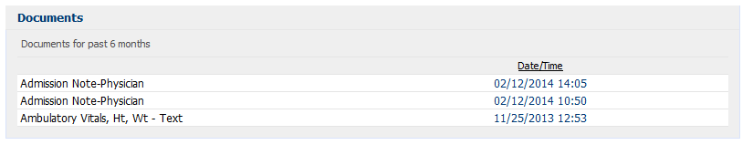
Exercise #13: Allergies Section with JSON
Objective: Introduction to placing data that is returned from a CCL query into JSON using CNVTRECTOJSON. For this exercise, we will perform a query for allergy information and place it into a record which will later be transformed to a JSON string. This will replace your current allergies component which uses XML.

- Create a new ccl program. This program will perform a CCL query to retrieve allergy information. The program will also store to a record and use CNVTRECTOJSON to return a JSON string.
- In Discern Visual Developer, open a new blank file. Save the file to the backend server (i.e. ccluserdir) as zzz_mpage_allergies_json.prg where zzz is your initials.
- Copy the code between the dashed lines below and paste into your zzz_mpage_allergies_json.prg. Replace the zzz in the ‘drop’ and ‘create’ commands with your initials.
- Save and include your zzz_mpage_allergies_json.prg.
-----------------------------------------------------------------------------------------------------------

drop program zzz_mpage_allergies_json:dba go
create program zzz_mpage_allergies_json:dba

prompt
"Output to File/Printer/MINE" = "MINE"
, "Person Id:" = 0.0

with outdev, personid

/*
Creates a JSON object as follows:

{
"ALLERGIES": {
"ALLERGY": [
{
"ALLERGY_NAME": "Adhesive bandage",
"ALLERGY_REACTION": "None Documented",
"ALLERGY_ID": 1.0
},
{
"ALLERGY_NAME": "Ambien",
"ALLERGY_REACTION": "Coma (3)",
"ALLERGY_ID": 2.0
},
{
"ALLERGY_NAME": "Tylenol",
"ALLERGY_REACTION": "None Documented",
"ALLERGY_ID": 3.0
},
{
"ALLERGY_NAME": "aspirin",
"ALLERGY_REACTION": "Nausea",
"ALLERGY_ID": 4.0
},
{
"ALLERGY_NAME": "penicillins",
"ALLERGY_REACTION": "Hives, flourescent green rash",
"ALLERGY_ID": 5.0
}
]
}
}

*/
free record ALLERGIES
record ALLERGIES (
1 ALLERGY[*]
2 ALLERGY_NAME = vc
2 ALLERGY_REACTION = vc
2 ALLERGY_ID = f8
)

/**************************************************
* Get the Allergies and Reactions *
**************************************************/

declare reactionString = vc with public, noconstant("")

select into "nl:"
sortName = if( n.nomenclature_id = 0 and TRIM( a.substance_ftdesc ) != "" )
cnvtupper(a.SUBSTANCE_FTDESC)
else
cnvtupper(n.SOURCE_STRING)
endif

from
allergy a,
nomenclature n,
reaction r,
nomenclature n2

plan a
where a.person_id = $PersonId
and a.substance_nom_id > 0.0
and a.cancel_dt_tm = NULL
and a.active_ind + 0 = 1

join n
where n.nomenclature_id = a.substance_nom_id

join r
where r.allergy_id = outerjoin(a.allergy_id)
and r.end_effective_dt_tm > outerjoin(cnvtdatetime(curdate,curtime3))
and r.active_ind = outerjoin(1)

join n2
where n2.nomenclature_id = outerjoin(r.reaction_nom_id)

order by sortName, a.allergy_id

head report
cnt = 0
reactionString = ""

head a.allergy_id
cnt = cnt+1
if (cnt > size(ALLERGIES->ALLERGY,5))
stat = alterlist(ALLERGIES->ALLERGY,cnt + 9)
endif

reactionString = ""

if( n.nomenclature_id = 0 and TRIM( a.substance_ftdesc ) != "" )
ALLERGIES->ALLERGY[cnt].ALLERGY_NAME = BUILD(a.SUBSTANCE_FTDESC)
else
ALLERGIES->ALLERGY[cnt].ALLERGY_NAME = BUILD(n.SOURCE_STRING)
endif

detail
if( n2.nomenclature_id = 0 and TRIM( r.reaction_ftdesc ) != "" )
if(reactionString > " ")
reactionString = build2(reactionString,", ",trim(r.reaction_ftdesc,3))
else
reactionString = concat(trim(r.reaction_ftdesc,3))
endif
else
if(reactionString > " ")
reactionString = build2(reactionString,", ",trim(n2.source_string,3))
else
reactionString = concat(trim(n2.source_string,3))
endif
endif

foot a.allergy_id
if (reactionString = "")
reactionString = "None Documented"
endif
ALLERGIES->ALLERGY[cnt].ALLERGY_REACTION = trim(reactionString,3)
ALLERGIES->ALLERGY[cnt].ALLERGY_ID = a.allergy_id

foot report
stat = alterlist(ALLERGIES->ALLERGY,cnt)

with nocounter

call echorecord(ALLERGIES)

;Set public memory variable equal to our XML string
set _Memory_Reply_String = CNVTRECTOJSON(ALLERGIES)

free record ALLERGIES

end
go

-----------------------------------------------------------------------------------------------------------

- Open your zzz_mpage.js. Comment out the old allergyInfoTable function using a block comment (ie. /* */), and add the new allergyInfoTable function between the dashed lines below just after your newly commented out code. Replace the ZZZ in ZZZ_MPAGE_ALLERGIES_JSON with your initials. The new allergyInfoTable function will be discussed by the instructor. Save zzz_mpage.js.

-----------------------------------------------------------------------------------------------------------

function allergyInfoTable(){
// Initialize the request object
var allInfo = new XMLCclRequest();

// Get the response
allInfo.onreadystatechange = function () {
if (allInfo.readyState == 4 && allInfo.status == 200) {
var msgAllergy = allInfo.responseText;

if (msgAllergy != undefined && msgAllergy != null && msgAllergy > " ") {
var jsonAllergy = eval('(' + msgAllergy + ')');
}

if (jsonAllergy){
var tableBody = ["<table>"];
for (var i=0,aLen=jsonAllergy.ALLERGIES.ALLERGY.length;i<aLen;i++) {
var allergyObj = jsonAllergy.ALLERGIES.ALLERGY[i];

tableBody.push(
"<tr class='allergyRow'>",
"<td class='col1'>", allergyObj.ALLERGY_NAME,"</td>",
"<td class='col2'>", allergyObj.ALLERGY_REACTION,"</td>",
"</tr>");
} // end for

// Close the table
tableBody.push("</table>");

// Insert the table into the allergy section
document.getElementById('allergyTable').innerHTML = tableBody.join("")

// This will do alternate row shading with jquery
//$('tr.allergyRow:odd').addClass('odd_row');
} //if (jsonAllergy)
}; //if
} //function

// Call the ccl progam and send the parameter string
allInfo.open('GET', "ZZZ_MPAGE_ALLERGIES_JSON");
allInfo.send("MINE, $PAT_Personid$");

return;
}
-----------------------------------------------------------------------------------------------------------

- Login to Power Chart if you haven’t already, and open the chart for a patient that has allergies. Verify that the Allergies section is populated with allergies.
- In the previous allergy section exercise using XML, we did the alternate row shading “the hard way”. Let’s do the alternate row shading in the new allergyInfoTable function with one line of jquery code.
- In the allergyInfoTable function, uncomment the following line (remove the // from the beginning of the line). Save zzz_mpage.js.
-----------------------------------------------------------------------------------------------------------
// $('tr.allergyRow:odd').addClass('odd_row');
-----------------------------------------------------------------------------------------------------------
- Stylesheet should not need updating since this style definition already exists in the CSS.
- Open a patient chart in Power Chart for a patient that has more than one allergy. Observe the alternating row colors.

Bonus Exercises
- Update the Allergy JSON CCL object to return a CNT variable for how many objects are in the list, and validate it running the CCL script from DvDev. This piece of data will not be used on the front-end, but please validate the newly formed JSON by looking at the listing.

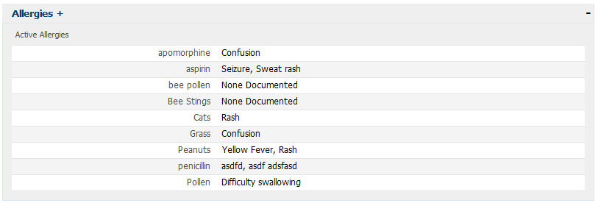

Exercise #14: Update Custom Driver Program
Objective: Update CCL Driver Script to utilize custom context variables and provide a means to debug MPages more effectively.
- In Discern Visual Developer, open or switch the tab of your zzz_mpage_driver.prg file.
- Update the script by adding in the pieces highlighted below in yellow.
- Save and build/include your zzz_mpage_driver.prg.
-----------------------------------------------------------------------------------------------------------
drop program zzz_mpage_driver:dba go
create program zzz_mpage_driver:dba

prompt
"Output to File/Printer/MINE" = "MINE"
,"Patient Id:" = 0.0
,"Encounter Id:" = 0.0
,"User Id:" = 0.0
,"Static Content Directory:" = ""
,"HTML File:" = "ccluserdir:zzz_mpage.html"
with outdev, person_id, encntr_id, user_id, sourcedir, html_file

/***************************************************************************
* Declare Records *
***************************************************************************/
free record mpage_rec
record mpage_rec (
1 person_id = f8
1 encntr_id = f8
1 user_id = f8
1 source_dir = vc
1 html_file = vc
)

/***************************************************************************
* Assign prompts to record structure *
***************************************************************************/
set mpage_rec->person_id = $person_id
set mpage_rec->encntr_id = $encntr_id
set mpage_rec->user_id = $user_id
set mpage_rec->source_dir = $sourcedir
set mpage_rec->html_file = $html_file

/***************************************************************************
* Read in HTML and display error HTML if incorrect *
***************************************************************************/
record getREQUEST (
1 Module_Dir = vc
1 Module_Name = vc
1 bAsBlob = i2
)

record getREPLY (
1 INFO_LINE[*]
2 new_line = vc
1 data_blob = gvc
1 data_blob_size = i4
%i cclsource:status_block.inc
)

; Read in the html file
set getrequest->module_dir= trim(mpage_rec->html_file, 3)
set getrequest->Module_name = ""
set getrequest->bAsBlob = 1
execute eks_get_source with replace (REQUEST,getREQUEST),replace(REPLY,getREPLY)
if(getREPLY->status_data.status = "F")
; Output No HTML File Found!
set getReply->data_blob = BUILD2(
^<html><head><title>MPage Error</title></head>^,
^<body><div>HTML file "^,mpage_rec->html_file,^" could not be found!</div>^,
CHAR(10),CHAR(13),
^</body></html>^
)
endif

/***************************************************************************
* Replace special strings in HTML File *
***************************************************************************/
; Replace $SOURCE_DIR$ in the HTML file with the actual location of the static_content files
set getReply->data_blob = replace(getReply->data_blob,"$SOURCE_DIR$", mpage_rec->source_dir,0)

; Replace $MPAGE_REC$ in the HTML file with the JSON for the record
set getReply->data_blob = replace(getReply->data_blob,"$MPAGE_REC$", CNVTRECTOJSON(mpage_rec),0)

/***************************************************************************
* Outputs HTML to the display *
***************************************************************************/
set _MEMORY_REPLY_STRING = getReply->data_blob

#exit_script
free record mpage_rec

end
go

-----------------------------------------------------------------------------------------------------------
- The hard-coded references to the front-end files will to be replaced in your zzz_mpage.html. Modify your zzz_mpage.html to replace the <your save location>\YourID\ as highlighted in yellow below. Select only the lines highlighted in yellow and paste them in the exact location shown below. Remember to replace the zzz with your initials.

-----------------------------------------------------------------------------------------------------------

<head>
<meta http-equiv="Content-Type" content="XMLCCLREQUEST,APPLINK,MPAGES_EVENT" name="discern"/>

<script language="javascript" type="text/javascript" src="$SOURCE_DIR$\js\jquery.min.js"></script>
<script language="javascript" type="text/javascript" src="$SOURCE_DIR$\js\zzz_mpage_common.js"></script>
<script language="javascript" type="text/javascript" src="$SOURCE_DIR$\js\zzz_mpage.js"></script>
<link href="$SOURCE_DIR$\css\zzz_mpage.css" rel="stylesheet" type="text/css"></link>
</head>

-----------------------------------------------------------------------------------------------------------

- Add the following lines in the head of the html after the link to your other scripts. This piece of code creates a global reference to the data passed to the driver script.

-----------------------------------------------------------------------------------------------------------

<script language="javascript" type="text/javascript">
var MPAGE_REC = $MPAGE_REC$.MPAGE_REC;
</script>

-----------------------------------------------------------------------------------------------------------

- Update references to context variables in javascript (ie. $pat_personid$, $vis_encntrid$) with their respective values on the global MPAGE_REC javascript variable. Use of these new variables will allow our MPage to work within DvDev again. Replace each as follows in zzz_mpage.js file. (NOTE that we are NOT updating the references in addAllergy or tabLink because they won’t work in DvDev regardless):

-----------------------------------------------------------------------------------------------------------

//docInfo.send("MINE, $PAT_Personid$, $VIS_Encntrid$");
docInfo.send("MINE, "+MPAGE_REC.PERSON_ID+".0, "+MPAGE_REC.ENCNTR_ID+".0");

-----------------------------------------------------------------------------------------------------------

//allInfo.send("MINE, $PAT_Personid$");
allInfo.send("MINE, "+MPAGE_REC.PERSON_ID+".0");

-----------------------------------------------------------------------------------------------------------

//patInfo.send("MINE, $PAT_Personid$");
patInfo.send("MINE, "+MPAGE_REC.PERSON_ID+".0");

-----------------------------------------------------------------------------------------------------------

- Save zzz_mpage.html and zzz_mpage.js.
- After all these changes, the MPage can now be run from DiscernVisualDeveloper OR Powerchart. To validate this, run the MPage in DvDev using the prompts for your updated driver. For the User Id prompt, you can pass 0.0 for now.

Bonus Exercises
- Setup the MPage with the new prompts for Powerchart using the Prefmaint tool. Use the following for context variables, and completely close Powerchart for the changes in PrefMaint to take effect after you save your changes:
  - Person Id ➔ $PAT_PERSONID$
  - Encounter Id ➔ $VIS_ENCNTRID$
  - User Id ➔ $USR_PERSONID$

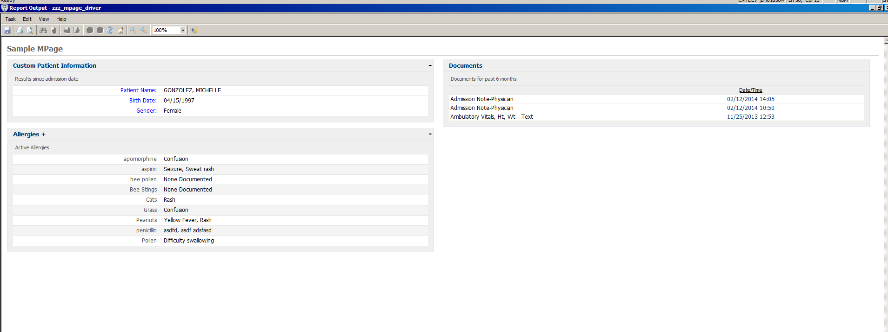
Exercise #15: Edge / Chromuim Browser Compatibility
Objective: Make changes to Javascript, PrefMaint etc to open Mpage in an Edge Viewer rather than an IE browser. Mpage 9.0 and above recommends to move to Edge browser setting as the support for IE browser would be removed soon.
- In Prefmaint, open the chart settings and go to the respective Discern Reports and set the WEB_BROWSER_SELECTION from “0-Internet Explorer” to “1-Edge Chromium” and Apply.
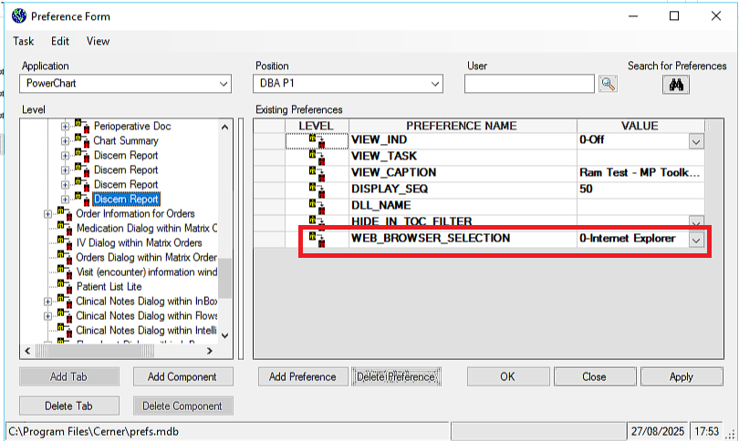

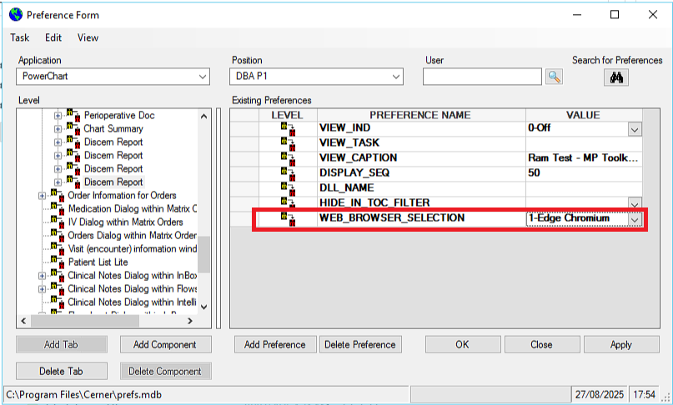

- Update zzz_mpage_documents.prg by copying and pasting entire code below to convert the ouput to JSON format instead of XML. This is needed to simplify asynchronous calls needed in Javascript.
-----------------------------------------------------------------------------------------------------------
drop program zzz_mpage_documents:dba go
create program zzz_mpage_documents:dba
prompt
"Output to File/Printer/MINE" = "MINE"
, "Person Id:" = 0.0
, "Encounter Id:" = 0.0
with outdev, personid, encntrid
free record documents
record documents (
1 document[*]
2 event_id = f8
2 title = vc
2 date = vc
)
declare inErrorCd = f8 with public, noconstant(uar_get_code_by("MEANING",8,"INERROR"))
declare DOCCd = f8 with public,constant(uar_get_code_by("MEANING", 53, "DOC"))

/******************************************************
* Get the Document Title, Date and Event_Id *
******************************************************/
select into "nl:"
evtDate = format(ce.event_end_dt_tm,"mm/dd/yyyy hh:mm;;dq"),
evtTitle = ce.event_tag,
evtId = cnvtstring(ceb.event_id)
from
clinical_event ce,
ce_blob ceb
plan ce
where ce.person_id = $PersonId
and ce.event_end_dt_tm >= cnvtlookbehind("6 M",cnvtdatetime(curdate,curtime3))
and ce.valid_until_dt_tm > cnvtdatetime(curdate,curtime3)
and ce.encntr_id = $encntrid
and ce.result_status_cd != inErrorCd
and ce.event_class_cd = DOCCd
join ceb
where ceb.event_id = ce.event_id
and ceb.valid_until_dt_tm > cnvtdatetime(curdate,curtime3)
order by ce.event_end_dt_tm desc
head ceb.event_id
cnt = cnt + 1
if (size(documents->document,5)<cnt)
stat = alterlist(documents->document, cnt+10)
endif
documents->document[cnt].event_id = ceb.event_id
documents->document[cnt].title = ce.event_tag
documents->document[cnt].date = format(ce.event_end_dt_tm,"mm/dd/yyyy hh:mm;;dq")
with nocounter
call echorecord(documents)
set _Memory_Reply_String = CNVTRECTOJSON(documents)
end
go
-----------------------------------------------------------------------------------------------------------
- Don’t forget to change zzz to your ID.
- Save and build/include this program.
- Do the same change for zzz_mpage_patientinfo.prg as well by copying and pasting the code below
-----------------------------------------------------------------------------------------------------------
drop program zzz_mpage_patientinfo:dba go
create program zzz_mpage_patientinfo:dba

prompt
"Output to File/Printer/MINE" = "MINE"
, "Person Id:" = 0.0
with outdev, personid

free record patinfo
record patinfo (
1 info[*]
2 label = vc
2 data = vc
2 hover = vc
)

/**************************************************
* Get the Patient Name, DOB and Gender *
**************************************************/
select into "nl:"
dob = format(p.birth_dt_tm,"mm/dd/yyyy;;d"),
gender = uar_get_code_display(p.sex_cd)
from
person p
plan p
where p.person_id = $personId

head report

stat = alterlist(patinfo->info, 3)
patinfo->info[1].label = "Patient Name : "
patinfo->info[1].data = p.name_full_formatted
patinfo->info[1].hover = build2("This person's name is: ", p.name_full_formatted)

patinfo->info[2].label = "Birth Date : "
patinfo->info[2].data = dob
patinfo->info[2].hover = build2("This person's birthdate is: ", dob)

patinfo->info[3].label = "Gender : "
patinfo->info[3].data = gender
patinfo->info[3].hover = build2("This person's gender is: ", gender)
with nocounter

call echorecord(patinfo)

set _Memory_Reply_String = CNVTRECTOJSON(patinfo)

end
go

-----------------------------------------------------------------------------------------------------------
- Don’t forget to change zzz to your ID. Save and build/include this program.
- Make changes to the html file as highlighted in yellow below. Select only the parts in lines highlighted in yellow and paste them in the exact location shown below. Remember to replace the zzz with your initials if you have copied the whole line.

-----------------------------------------------------------------------------------------------------------

<head>
<meta http-equiv="Content-Type" content="XMLCCLREQUEST,APPLINK,MPAGES_EVENT,CCLLINK" name="discern"/>
<script language="javascript" type="text/javascript" src="$SOURCE_DIR$\\jquery.js" charset="UTF-8"></script>
<script language="javascript" type="text/javascript" src="$SOURCE_DIR$\\zzz_mpage.js" charset="UTF-8"></script>
<script language="javascript" type="text/javascript" src="$SOURCE_DIR$\\zzz_mpage_common.js" charset="UTF-8"></script>
<script language="javascript" type="text/javascript">
var MPAGE_REC = $MPAGE_REC$.MPAGE_REC;
</script>
<link href="$SOURCE_DIR$\\zzz_mpage.css" rel="stylesheet" type="text/css" charset="UTF-8"/>
</head>
-----------------------------------------------------------------------------------------------------------

- Copy the whole code below and paste in zzz_mpage.js file. The ones highlighted in green are changes specific to Edge compatibility. Instructor will explain how asynchronous calls work and why it is needed for Edge/Chromium browsers.

-----------------------------------------------------------------------------------------------------------

function getEvents(){
// Call functions to format html and populate sections
patientInfoTable();
allergyInfoTable();
docTable();
}

//Add async for Edge Compatibility******************
async function patientInfoTable(){
//Added for Edge Compatibility ***Start********************
let patPromise = new Promise(function(resolve) {
//Added for Edge Compatibility ***End********************
// Initialize the request object
var patInfo = new XMLCclRequest();

// Get the response
patInfo.onreadystatechange = function () {
if (patInfo.readyState == 4 && patInfo.status == 200) {
var msgPatient = patInfo.responseText;
if (msgPatient != undefined && msgPatient != null && msgPatient > " ") {
var jsonPatient = eval('(' + msgPatient + ')');
}
if (jsonPatient){
var tableBody = ["<table>"];
for (var i=0,aLen=jsonPatient.PATINFO.INFO.length;i<aLen;i++) {
var patObj = jsonPatient.PATINFO.INFO[i];

tableBody.push(
"<tr>",
"<td class='col1'>", patObj.LABEL,"</td>",
"<td class='col2' title=\"",patObj.HOVER,"\">",patObj.DATA,"</td>",
"</tr>");
} // end for

// Close the table
tableBody.push("</table>");

// Insert the table into the patient information section
document.getElementById('patientInfoTable').innerHTML = tableBody.join("");

var link = tabLink("Custom Patient Information","Patient Information","$APP_APPNAME$");

// Insert the link into the patient information section header
document.getElementById('patHeader').innerHTML = link;

//Added for Edge Compatibility ***Start********************
resolve("Finished getting Patient data");
//Added for Edge Compatibility ***End********************

//Initialize the col2 elements as hovers
$.reInitPopUps('patientInfoTable');
} //if (jsonPatient)
}; //if
} //function

// Call the ccl progam and send the parameter string
//Add ,true for Edge Compatibility******************
patInfo.open('GET', "ZZZ_MPAGE_PATIENTINFO",true);
//patInfo.send("MINE, $PAT_Personid$");
patInfo.send("MINE, "+MPAGE_REC.PERSON_ID);
//patInfo.send("MINE,1416145.00");
//Added for Edge Compatibility ***Start********************
});
console.log("starting to wait for promise");
var waitForPromise = await patPromise;
console.log(waitForPromise);
//Added for Edge Compatibility ***End********************
// return;
}

//Add async for Edge Compatibility******************
async function allergyInfoTable(){
//Added for Edge Compatibility ***Start********************
let algPromise = new Promise(function(resolve) {
//Added for Edge Compatibility ***End********************

// Initialize the request object
var allInfo = new XMLCclRequest();

// Get the response
allInfo.onreadystatechange = function () {
if (allInfo.readyState == 4 && allInfo.status == 200) {
var msgAllergy = allInfo.responseText;

if (msgAllergy != undefined && msgAllergy != null && msgAllergy > " ") {
var jsonAllergy = eval('(' + msgAllergy + ')');
}

if (jsonAllergy){
var tableBody = ["<table>"];
for (var i=0,aLen=jsonAllergy.ALLERGIES.ALLERGY.length;i<aLen;i++) {
var allergyObj = jsonAllergy.ALLERGIES.ALLERGY[i];

tableBody.push(
"<tr class='allergyRow'>",
"<td class='col1'>", allergyObj.ALLERGY_NAME,"</td>",
"<td class='col2'>", allergyObj.ALLERGY_REACTION,"</td>",
"</tr>");
} // end for

// Close the table
tableBody.push("</table>");

// Insert the table into the allergy section
document.getElementById('allergyTable').innerHTML = tableBody.join("")
//Added for Edge Compatibility ***Start********************
resolve("Finished getting Allergy data");
//Added for Edge Compatibility ***End********************
// This will do alternate row shading with jquery
$('tr.allergyRow:odd').addClass('odd_row');
} //if (jsonAllergy)
}; //if
} //function

// Call the ccl progam and send the parameter string
//Add ,true for Edge Compatibility******************
allInfo.open('GET', "ZZZ_MPAGE_ALLERGIES_JSON",true);
//allInfo.send("MINE, $PAT_Personid$");
allInfo.send("MINE, "+MPAGE_REC.PERSON_ID);
//Added for Edge Compatibility ***Start********************
});
console.log("starting to wait for promise");
var waitForPromise = await algPromise;
console.log(waitForPromise);
//Added for Edge Compatibility ***End********************
// return;
}

//Add async for Edge Compatibility******************
async function docTable(){
//Added for Edge Compatibility ***Start********************
let docPromise = new Promise(function(resolve) {
//Added for Edge Compatibility ***End********************

// Initialize the request object
var docInfo = new XMLCclRequest();

// Get the response
docInfo.onreadystatechange = function () {
if (docInfo.readyState == 4 && docInfo.status == 200) {
// var xmlDoc = loadXMLString(docInfo.responseText);
var xmlDoc = docInfo.responseText;
if (xmlDoc != undefined && xmlDoc != null && xmlDoc > " ") {
var jsonDoc = eval('(' + xmlDoc + ')');
}

if (jsonDoc){
var tableBody = ["<table>"];
// Start building the patient information table
var tableBody = [
"<table>",
"<thead>",
"<tr>",
"<td class='diagnosticsCol1Hdr'>&nbsp;</td>",
"<td class='diagnosticsCol3Hdr'>Date/Time</td>",
"</tr>",
"</thead>",
"<tbody>"];

for (var i=0,aLen=jsonDoc.DOCUMENTS.DOCUMENT.length;i<aLen;i++) {
var docObj = jsonDoc.DOCUMENTS.DOCUMENT[i];
var paramStr = "^MINE^,"+docObj.EVENT_ID;

tableBody.push(
"<tr>",
"<td class='diagnosticsCol1'>", docObj.TITLE,"</td>",
"<td class='diagnosticsCol2'><a href=\"javascript:CCLLINK( 'mp_rtf_view', '"+paramStr+"', 0)\";>",docObj.DATE,"</a></td>",
"</tr>");
} // end for

// Close the table
tableBody.push("</table>");

// Insert the table into the patient information section
document.getElementById('documentTable').innerHTML = tableBody.join("");
//Added for Edge Compatibility ***Start********************
resolve("Finished getting Document data");
//Added for Edge Compatibility ***End********************
} //if (jsonAllergy)

}; //if
} //function

// Call the ccl progam and send the parameter string
//Add ,true for Edge Compatibility******************
docInfo.open('GET', "ZZZ_MPAGE_DOCUMENTS",true);
//docInfo.send("MINE, $PAT_Personid$, $VIS_Encntrid$");
docInfo.send("MINE, "+MPAGE_REC.PERSON_ID+", "+MPAGE_REC.ENCNTR_ID);
//Added for Edge Compatibility ***Start********************
});
console.log("starting to wait for promise");
var waitForPromise = await docPromise;
console.log(waitForPromise);
//Added for Edge Compatibility ***End********************
// return;
}

function tabLink (desc,firstTab,appl) {
var nMode = 0;
var vcAppName = appl;
var vcDescription = desc;
var vcParams = "/PERSONID=$PAT_Personid$ /ENCNTRID=$VIS_Encntrid$ /FIRSTTAB="+firstTab;
return ["<a title='Click to go to ",firstTab," Tab' href='javascript:APPLINK(",nMode,",\"",vcAppName,"\",\"",vcParams,"\");'>",vcDescription,"</a>"].join("");
}

function addAllergy() {
var paramString = "$PAT_Personid$|$VIS_Encntrid$|0|0|||0||0|0";
MPAGES_EVENT("Allergy", paramString);
allergyInfoTable();
} //end addAllergy
-----------------------------------------------------------------------------------------------------------

- After all these changes, the MPage can now be run from Powerchart.
- Right-Click on the viewer to get context menu with options like “Refresh”, “Screenshot”. If appropriate permissions are given then “Inspect” option might be available whereby troubleshooting of issues is possible.

